News Page

Article 1

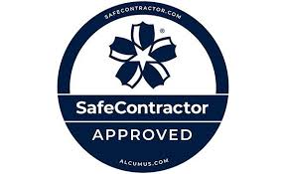

The Conveyor Belt Company (Scotland) is excited to announce that we have achieved the Alcumus Safe Contractor Gold Standard Certification. This recognition reflects our dedication to the health and safety of both our workforce and the quality of service we provide to our clients distinguishing us from our competition.
Alcumus Safe Contractor is a trusted third-party accreditation program that evaluates the health and safety practices, policies, and qualifications of contractors. Many leading clients recognize and accept the Safe Contractor certificate as proof of a company’s competency in health and safety.
As part of the Safe Contractor scheme, businesses undergo a comprehensive assessment to verify that their health and safety procedures meet high standards and that they have a proven track record of safe practices. Companies that meet the criteria are included on a database accessible to those seeking reliable services.
This achievement, alongside the appointment of our dedicated Health and Safety Manager, highlights The Conveyor Belt Co (Scotland’s) ongoing commitment to continuous improvement in this essential area.

